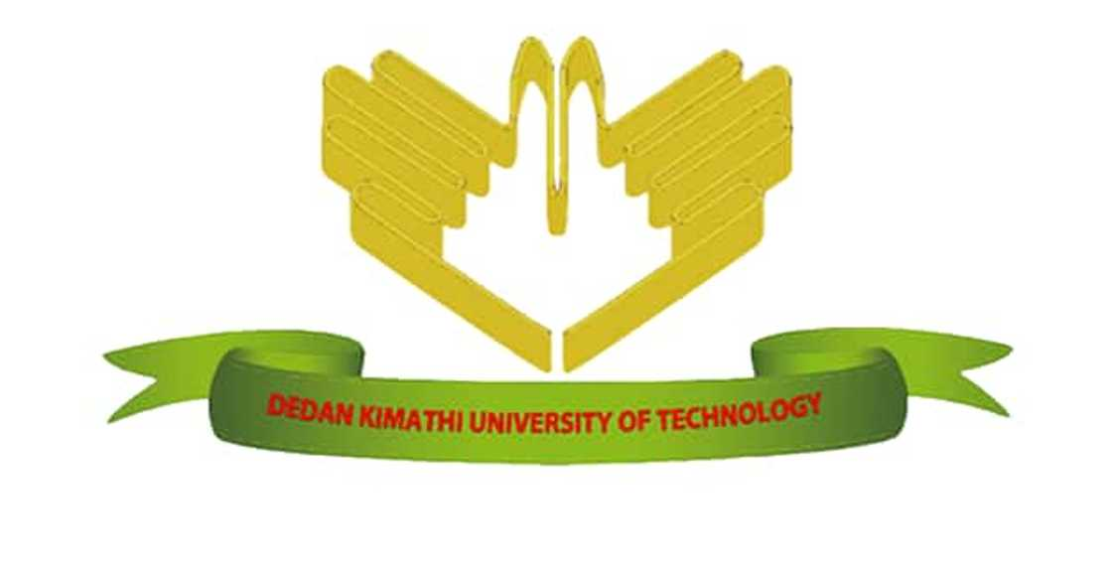
DEDAN KIMATHI UNIVERSITY OF TECHNOLOGY
SCHOOL OF COMPUTER SCIENCE AND INFORMATION TECHNOLOGY
BY
NAME: JAMES WAHITI
REGISTRATION NUMBER: C025-01-0832/2022
SUPERVISOR: DR. PATRICK GIKUNDA
CAPSTONE PROJECT: MODERN SOCIETY CHALLENGE
PROJECT TITLE
THE DIGITAL DIVIDE IN MODERN SOCIETY AND THE ROLE OF INFORMATION TECHNOLOGY IN BRIDGING THE GAP
An abstract submitted in partial fulfillment of the requirements for the award of the degree of Bachelor of Science in Information Technology of Dedan Kimathi University of Technology

January 2026

Abstract
This presentation examines the digital divide as a major challenge facing modern society and explores the role of information technology in addressing this problem. The digital divide refers to the gap between individuals and communities that have access to digital technologies and those that do not. In many developing regions, including parts of Africa, limited access to devices, internet connectivity, and digital skills has resulted in unequal opportunities in education, employment, and access to information.
Advancements in information technology offer practical solutions for reducing the digital divide. Affordable devices, localized digital infrastructure, offline-capable systems, and digital literacy programs can significantly improve access to information and communication technologies. In particular, locally deployed and low-bandwidth digital solutions can ensure that marginalized communities are not excluded from technological progress.
The presentation highlights how inclusive and sustainable use of information technology can promote social equity, enhance access to education and economic opportunities, and support long-term development. Addressing the digital divide is essential for ensuring that technological advancement benefits all members of society rather than widening existing inequalities.

Muhtasari
Uwasilishaji huu unachunguza mgawanyiko wa kidijitali kama changamoto kubwa inayokabili jamii ya kisasa na unajadili jukumu la teknolojia ya habari katika kushughulikia tatizo hili. Mgawanyiko wa kidijitali unarejelea tofauti iliyopo kati ya watu na jamii zilizo na upatikanaji wa teknolojia za kidijitali na zile zisizo nazo. Katika maeneo mengi yanayoendelea, ikiwemo sehemu za Afrika, ukosefu wa vifaa vya kidijitali, muunganisho wa mtandao, na ujuzi wa kidijitali umesababisha ukosefu wa usawa katika elimu, ajira, na upatikanaji wa taarifa.
Maendeleo katika teknolojia ya habari yanatoa suluhisho za vitendo za kupunguza mgawanyiko wa kidijitali. Vifaa vinavyopatikana kwa gharama nafuu, miundombinu ya kidijitali ya ndani, mifumo inayoweza kufanya kazi bila mtandao wa kudumu, na programu za mafunzo ya ujuzi wa kidijitali zinaweza kuboresha kwa kiasi kikubwa upatikanaji wa teknolojia za habari na mawasiliano. Hasa, mifumo ya ndani na inayotumia kiwango kidogo cha mtandao inaweza kuhakikisha kuwa jamii zilizotengwa haziachwi nyuma katika maendeleo ya kiteknolojia.
Kwa ujumla, uwasilishaji huu unaonesha jinsi matumizi jumuishi na endelevu ya teknolojia ya habari yanavyoweza kukuza usawa wa kijamii, kuboresha upatikanaji wa elimu na fursa za kiuchumi, na kusaidia maendeleo ya muda mrefu. Kushughulikia mgawanyiko wa kidijitali ni muhimu ili kuhakikisha kuwa maendeleo ya teknolojia yanawanufaisha wanajamii wote badala ya kuongeza tofauti zilizopo.

Muthabari
Uwasilishaji uyu urĩa gũcookereria mgawanyiko wa kidijitali ta mathĩna mũnene mũno ũrĩa ũkũrũkĩte jamii ya rũciũ na gũmenyithia ũrĩa tekinolojia ya habari yahotithagia gũcookeria mathĩna macio. Mgawanyiko wa kidijitali nĩ ũtukũrũ wa gũtandukania hagati ya andũ na jamii arĩa marĩ na ũhotithia wa tekinolojia cia kidijitali na arĩa matarĩ nawo. Kũrĩa handũ haingĩ ha gũtũũra, ta ciana cia Afrika, kũtĩkĩra ndũmũrũ cia kidijitali, mtandao, na ũmenyithia wa kidijitali nĩ gũrehia kũtandukania kwa elimu, wĩra, na gũkũhoya ũhoro.
Maendeleo ma tekinolojia ya habari maheana njira cia wĩra cia gũthikĩra mgawanyiko wa kidijitali. Ndũmũrũ iria ithikĩrĩro igiĩrĩro rĩnini, miundombinu ya kidijitali ya ndũmũrũ, mitĩrĩrũ iria ihotithagia gũtũũra ithina rĩa mtandao mũnene, na mĩtugo ya gũthoma ũmenyithia wa kidijitali ihotithagia gũthikĩra ũhotithia wa tekinolojia ya habari na ya gũkũrũkĩra. Mũno mũno, mitĩrĩrũ ya ndũmũrũ na iria ithina mtandao mũnini ihotithagia gũthikĩra atĩ jamii iria itarĩ ũhotithia itiga gũtina thirikari ya tekinolojia.
Mũno mũno, uwasilishaji uyu ũmenyithagia ũrĩa gũtũmĩtio wa tekinolojia ya habari kwa njira ya gũkũrũkĩrĩria na ya gũtũũra ihinda rĩa mũno ũhotithagia gũcookeria ũtukũrũ wa kijamii, gũcookeria ũhotithia wa elimu na wa mĩtugo ya ũgĩrĩrĩ, na gũthikĩra maendeleo ma ihinda rĩingĩ. Gũcookeria mgawanyiko wa kidijitali nĩ wa mũno nĩguo gũthikĩrĩre atĩ maendeleo ma tekinolojia magũteithia andũ othe kana gũtandũka mathĩna marĩa marĩho.

